**Computer Engineering Department**

**Course Name: CMPE-272**

**Homework #4**

**Submitted By: Team VentureNet**

Dvora Chitayat, Neelam Choudhary, Ankit Gupta, Manjeet Singh Brar

**Instructor:** Andrew Bond

**Lab Assignment #4:** Implementing Twitter Rest API’s.

**Semester:** Fall, 2015

**Abstract:**

**HotTwitt** application provides a quick and filtered interface to Twitter. The user can stay informed with the latest trends that interests him and ignore the other vast amount of data that Twitter provides. The user can easily stay up to date with the latest trends and then use the search button to zoom in on a specific top and get the latest information, for example, on breaking news, medical information, vacations and more.  The user has an option to update the followers.  The application provides a quick interface to manage user’s account as updating the account profile, posting a tweet, searching tweets, getting followers, follow a user, unfollow a user, retrieving user timeline.

The application consists of 1 text box that takes the input from the user and 8 buttons implementing the 8 different twitter API’s , on click of that particular button. The application is linked to the user’s twitter account and what ever task is performed from the application is implemented into the user’s twitter account. The HotTwitt app is authenticated using the **oauth2** python library.

The application implements the below 8 Twitter API’s:

1. Trending Topics.
2. Search Tweets.
3. Post a Tweet.
4. Update profile name.
5. Get Followers.
6. Follow a user.
7. Unfollow a User.
8. Retrieve user timeline.

**Test Cases:**

**Test Case #1**

**API:** Posting a Tweet.

**Description:** This api is used to post the tweets on user’s twitter account from the app.

**Resource Url:** <https://api.twitter.com/1.1/statuses/update.json>

|  |  |
| --- | --- |
| **Input** | **Expected Result** |
| * To post a tweet, enter the text in the textbox and click “Post Twitt” button. | The entered text is posted on the user’s twitter account as a new tweet. |

**Test Case #2**

**API:** Following a user.

**Description:** This api is used to follow a particular user on twitter. Just type the screen name of the user in the text box and click the “Follow a User” button.

**Resource Url:** <https://api.twitter.com/1.1/friendships/create.json>

|  |  |
| --- | --- |
| **Input** | **Expected Result** |
| * To follow any user, enter the screen name(twitter username) of that user in the textbox and click on the “Follow a User” button. | The authenticating user is now following that particular user on twitter. |

**Test Case #3**

**API:** Unfollow a user.

**Description:** This api is used to unfollow a user on twitter. Type the screen name of the user in the text box and click the “Unfollow a User” button.

**Resource Url:** <https://api.twitter.com/1.1/friendships/destroy.json>

|  |  |
| --- | --- |
| **Input** | **Expected Result** |
| * To unfollow a user, enter the twitter screen name(twitter username) of that user in the textbox and click on the “Unfollow a User” button. | The authenticating user is now not following that particular user on twitter. |

**Test Case #4**

**API:** Retrieve User Timeline.

**Description:** To retrieve the tweets from some particular user’s timeline.

**Resource Url:** <https://api.twitter.com/1.1/statuses/user_timeline.json>

|  |  |
| --- | --- |
| **Input** | **Expected Result** |
| * To retrieve the tweets from some particular user’s timeline, enter the twitter username of that user in the textbox and click on “User Timeline” button. | The tweets from that particular user’s time are fetched and displayed on the UI. |

**Test Case #5**

**API:** Search Tweets.

**Description:** To search the tweets from the twitter about any particular keyword.

**Resource Url:** <https://api.twitter.com/1.1/search/tweets.json>

|  |  |
| --- | --- |
| **Input** | **Expected Result** |
| * To search relevant tweets regarding any particular keyword, just type that keyword in the textbox and click on the “Search Twitts” button. | The tweets are retrieved from the twitter and displayed on the UI. |

**Test Case #6**

**API:** Update Name.

**Description:** To update the twitter profile from the HotTwitt app.

**Resource Url:** <https://api.twitter.com/1.1/account/update_profile.json>

|  |  |
| --- | --- |
| **Input** | **Expected Result** |
| * To update user’s screen name, type the new name to be updated in the textbox and click on “Update Name” button. | The screen name on the user’s twitter account is now updated with the new name. |

**Test Case #7**

**API:** Get Followers.

**Description:** To get the followers of some particular user.

**Resource Url:** <https://api.twitter.com/1.1/friendships/lookup.json>

|  |  |
| --- | --- |
| **Input** | **Expected Result** |
| * To search for someone’s followers, enter the twitter name of that user in the textbox and click the “Get Followers” button. | The followers of that particular user are retrieved and displayed on the UI. |

**Test Case #8**

**API:** Trending Topics.

**Description:** This returns the top 10 categories that Twitter has trending topic information.

**Resourse Url:** <https://api.twitter.com/1.1/trends/place.json?id=2450022>

|  |  |
| --- | --- |
| **Input** | **Expected Result** |
| * Click on the “Trending Topics” Button | Returns the top 10 categories that Twitter has trending topic information of USA. The user can then zoom in on the topic by entering the text and clicking on the “Search Tweets” button. |

**Test Case #9**

**Description:** Button click with empty text box except the “Trending Topics” buttons.

|  |  |
| --- | --- |
| **Input** | **Expected Result** |
| * Any button click with empty textbox except the “Trending Topics” button. | Returns a message box with the error message: “You cannot perform this function with empty textbox.” |

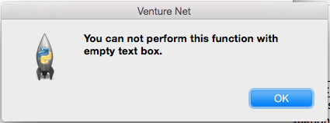

**Test Case #10**

**Description:** Entering more than 140 characters in the textbox to post tweet returns the error message.

|  |  |
| --- | --- |
| **Input** | **Expected Result** |
| * Enter more the 140 characters in the text box to post tweet by clicking on the “Post Twitt” button. | Returns a message box with the error message: “The text you have entered is more than 140 characters.”. |

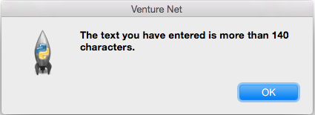

**UML Diagram:**

Authentication with Consumer Key and Secret

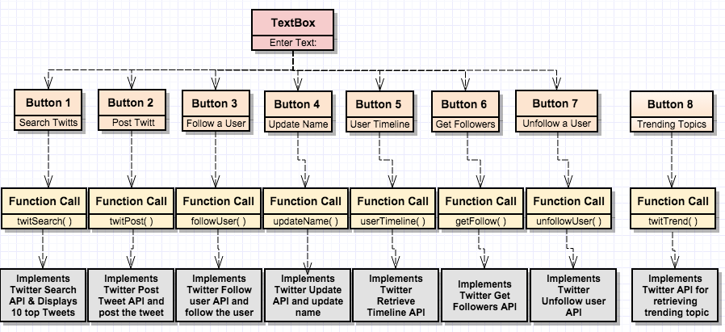

**Use cases and Screen Shot:**

Home page of the HotTwitt Application

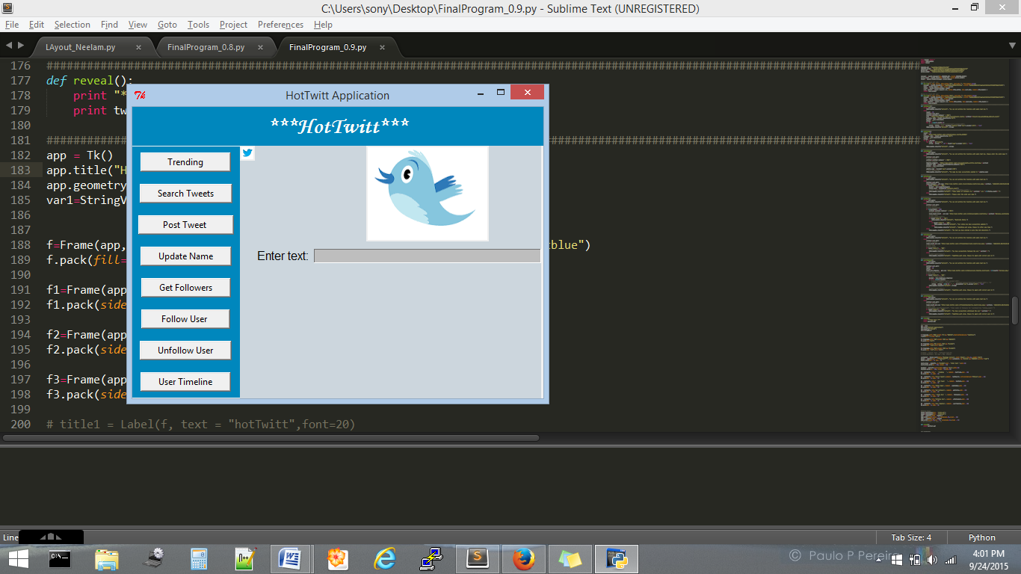

1. Click on “Trending” Button to see the list of top 10 trending topics:

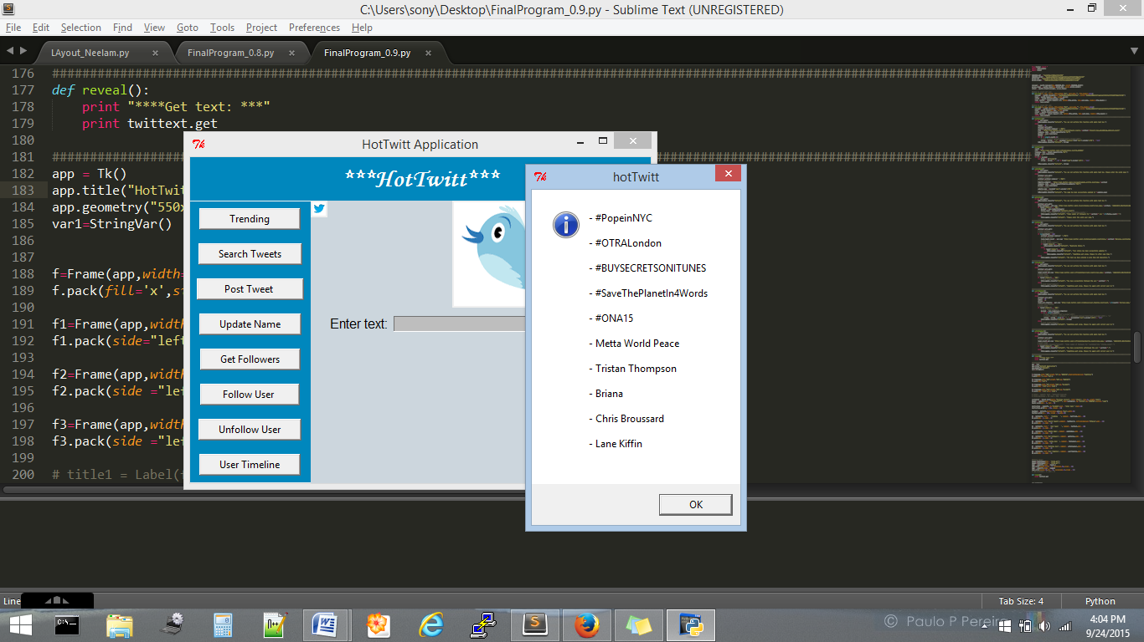

2. Now if user wants to search something related to these trending topic or any other topic then he can enter the text in given text-box and click on “Search Tweets” Button.

For example let’s enter the text= ‘ SaveThePlanetIn4Words’

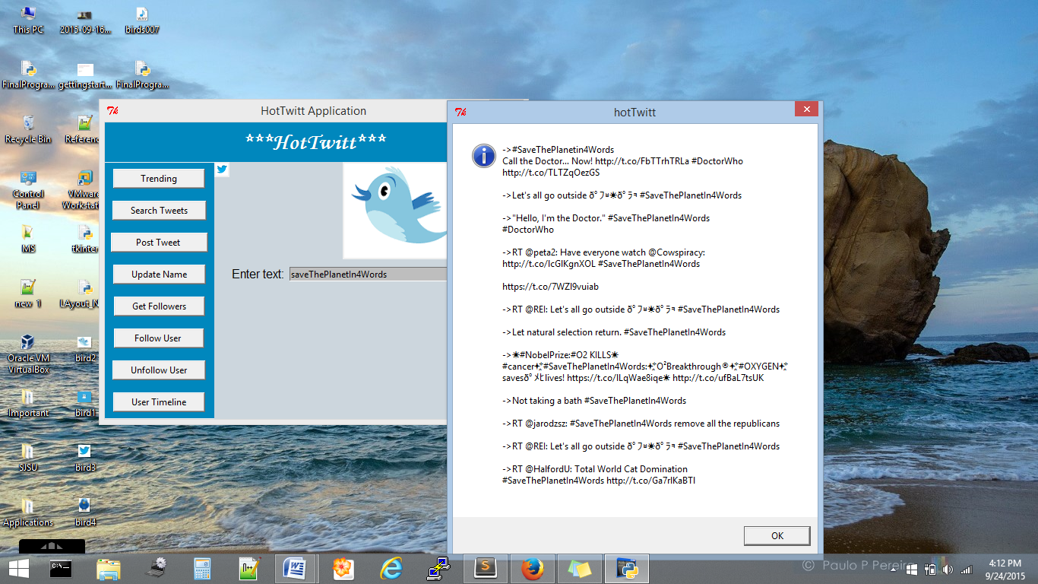

3. User can also post tweets to his account from this application. To post tweet enter text in text box(Max:140 Character) and click on button “Post tweet”. If character entered are more than 140, a error message will appear else status will be uploaded successfully.

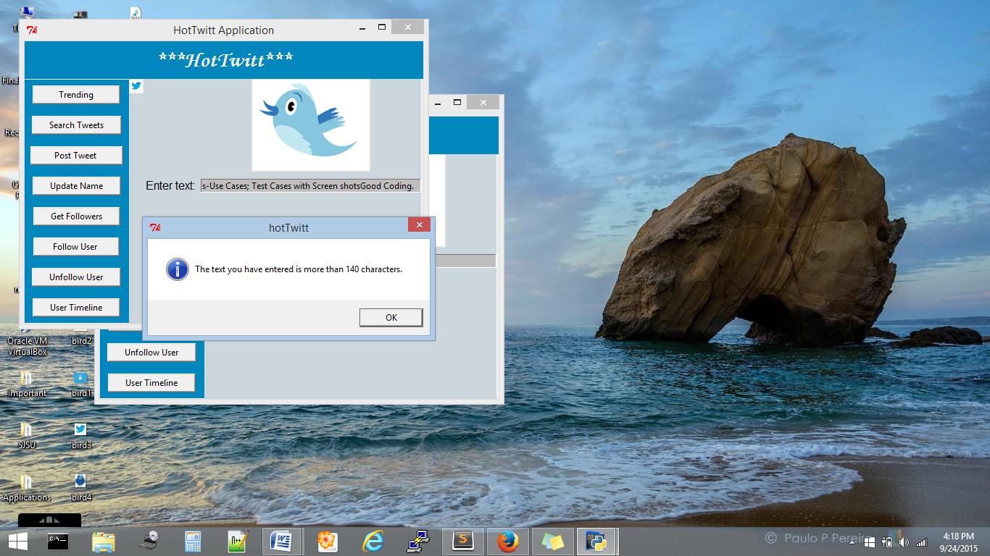

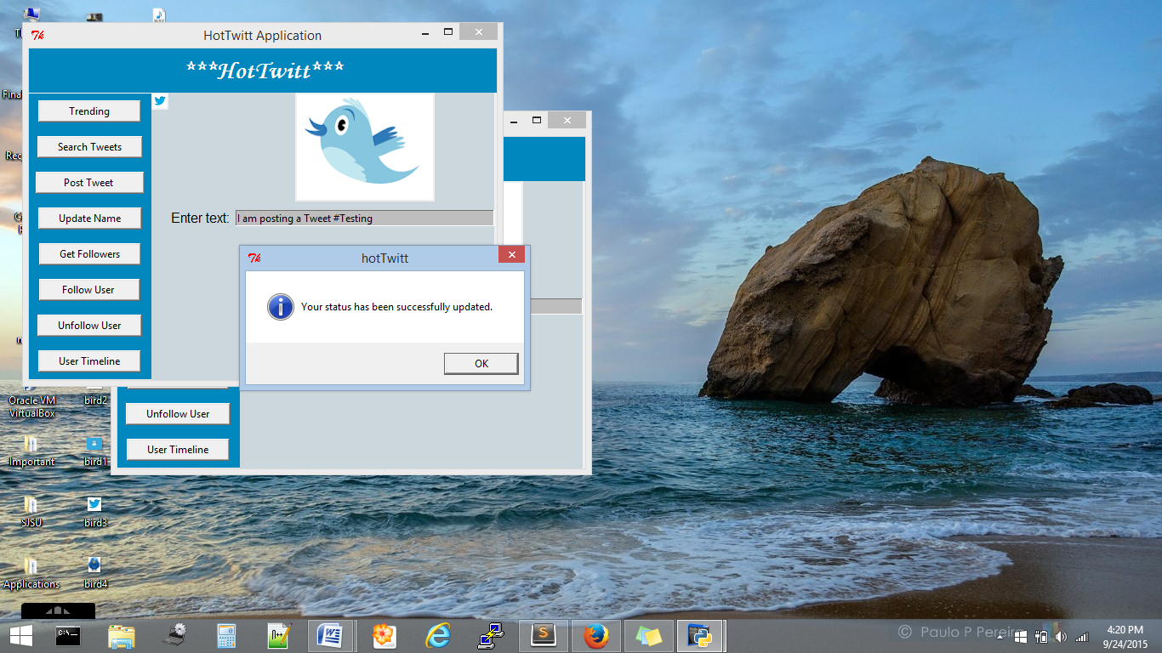

Status can be seen on the Twitter Timeline of User account:

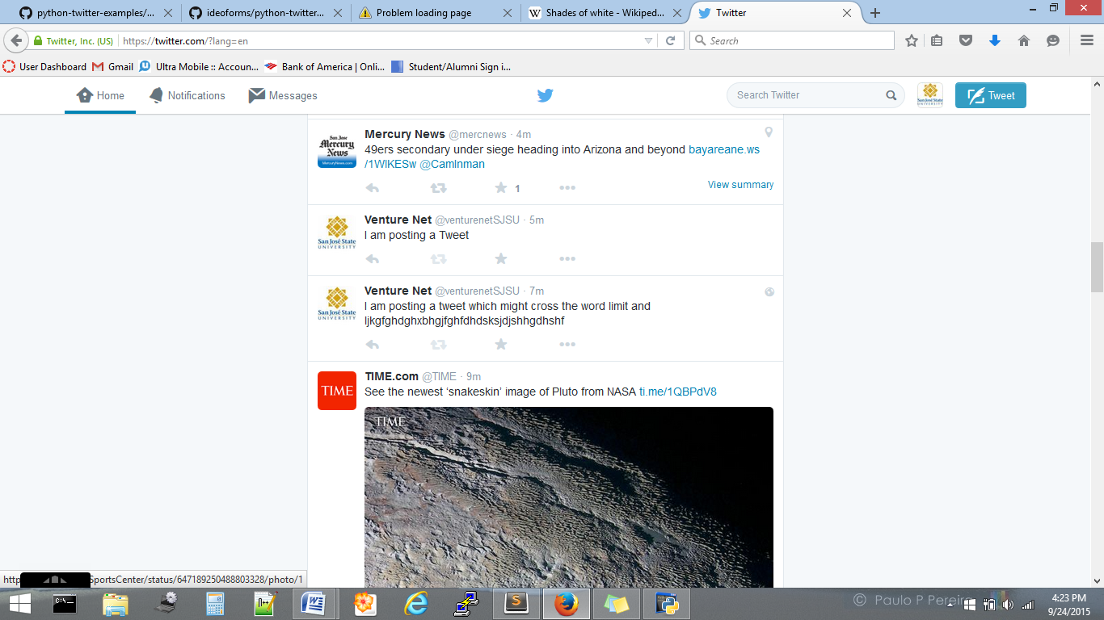

4. Now, to update the User name on user account then enter the name you want to update on the text box and click on “Update Name” Button. Name will be updated on the user account .

Example: I am changing my user name account from VentureNetSJSU to HotTwitt

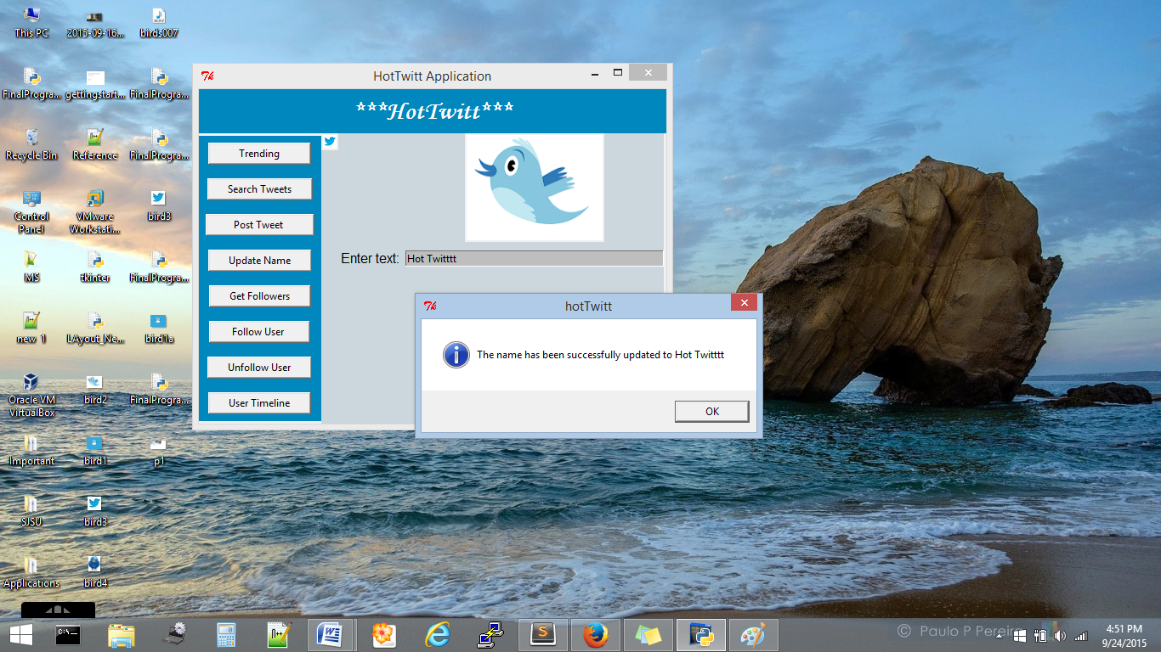

Name Successfully updated and can be seen in user account below

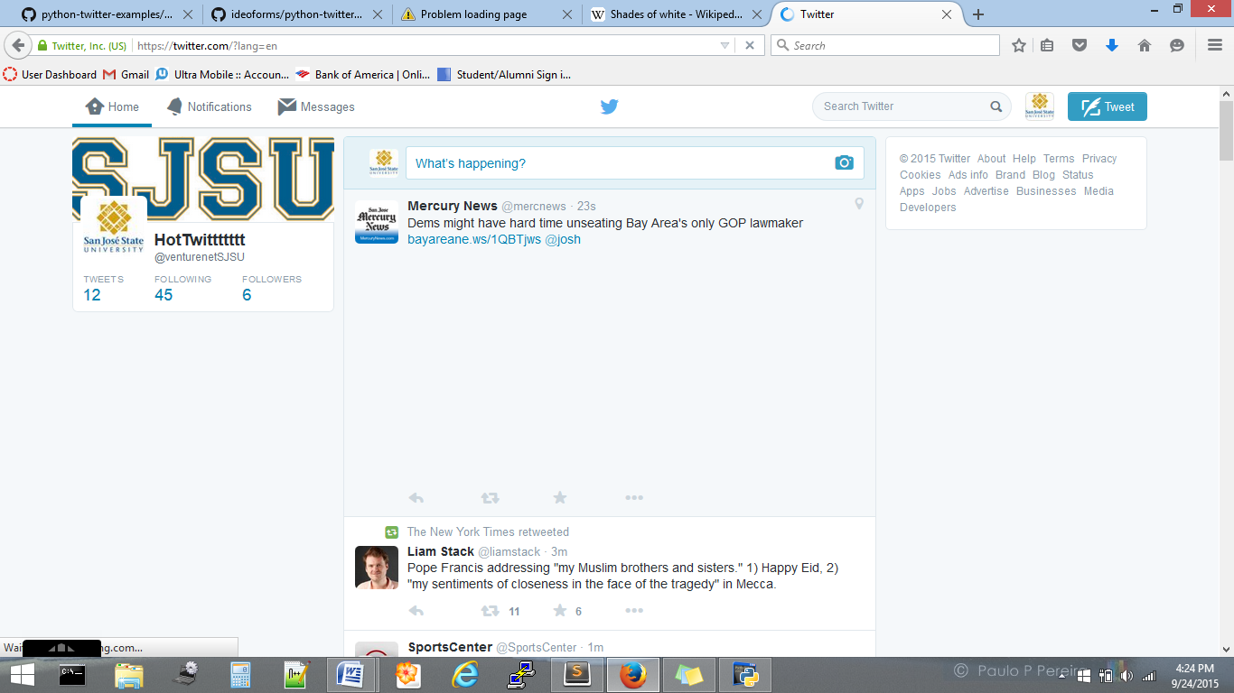

5. To get the number of followers, user can the account handle (unique to each account) in the text box and then click on “Get Followers” Button. It will return the number of followers a user has.

Example: VenturenetSJSU has 6 followers.

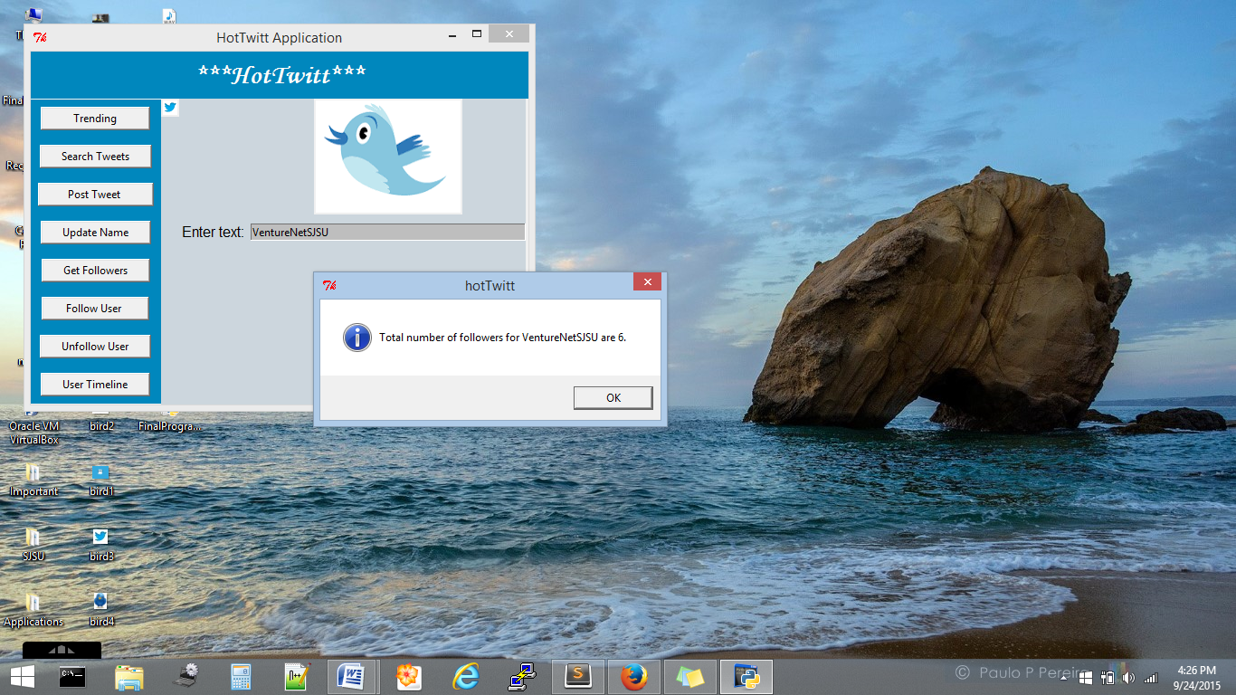

Application shows 6 followers which we can also see on user twitter account below-

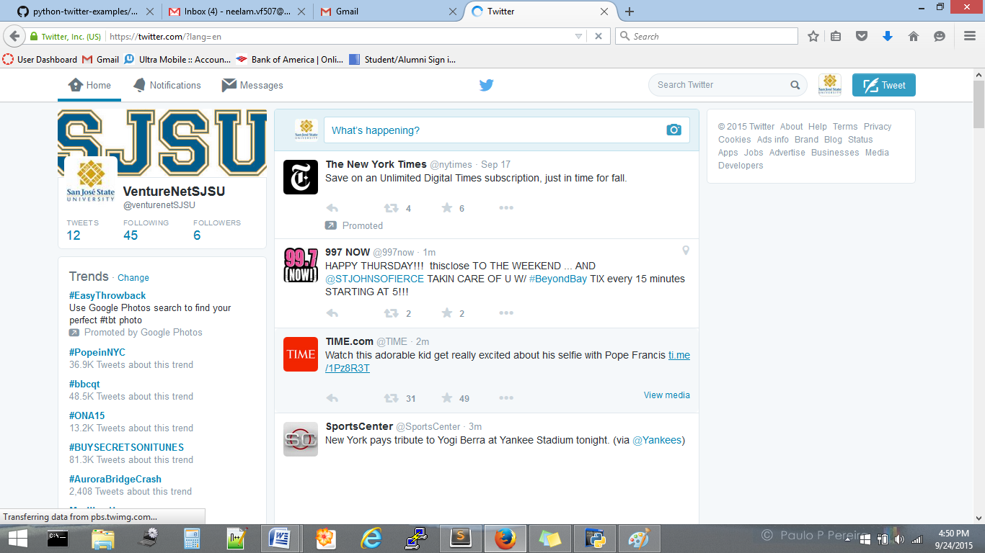

6. To follow a particular user account, we can write the account handle in the text box and click on “Follow User” Button.

You can see in the following images: We are following the National Geographic(@NatGeo). In background you can see status changes from follow to following after clicking the “follow” button

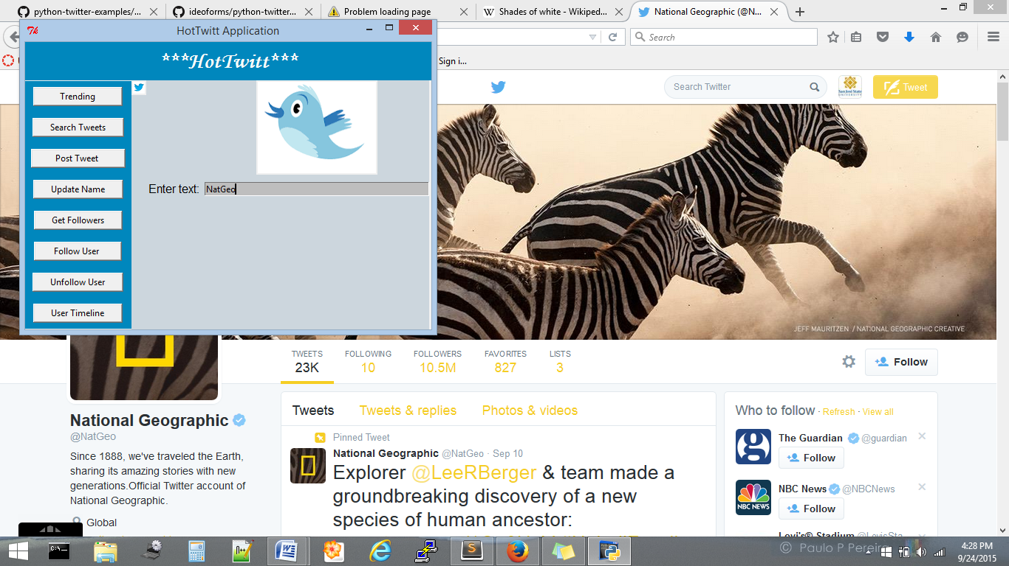

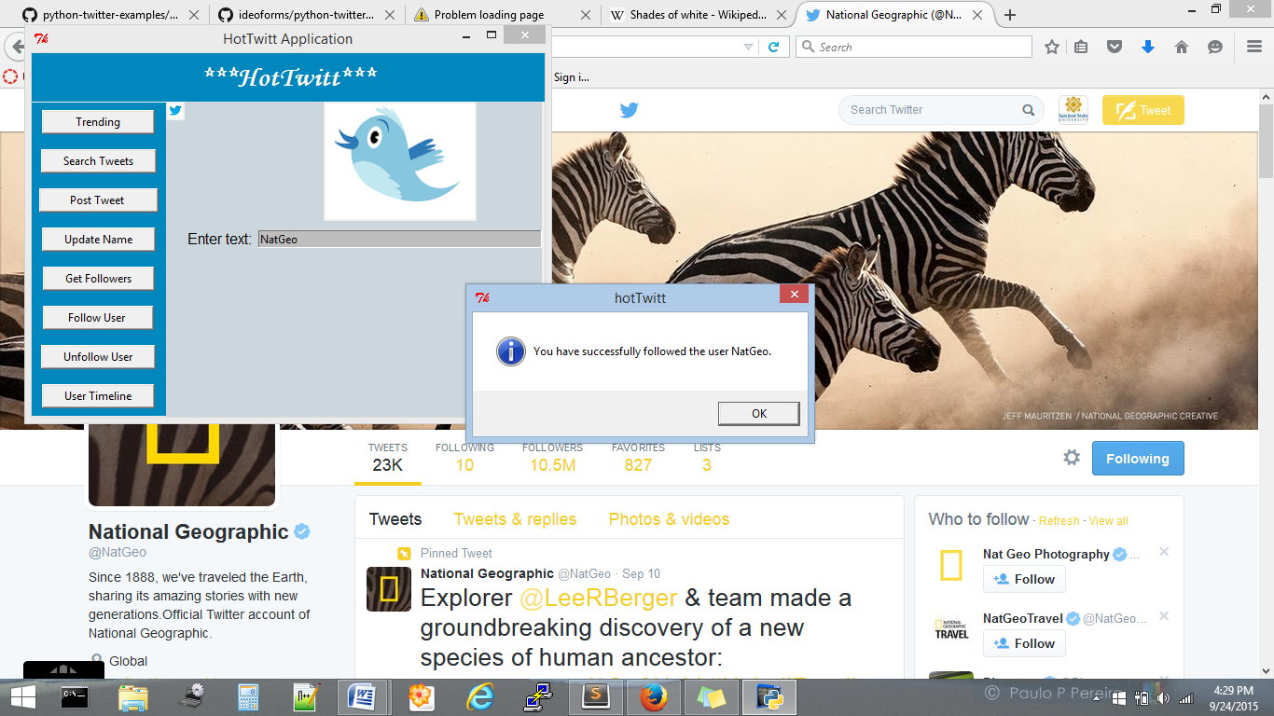

7. To unfollow a particular user account, we can write the account handle in the text box and click on “Unfollow User” Button.

You can see in the following images: We are unfollowing the NPR(@NPR). In background you can see status changes from following to follow after clicking the “unfollow” button

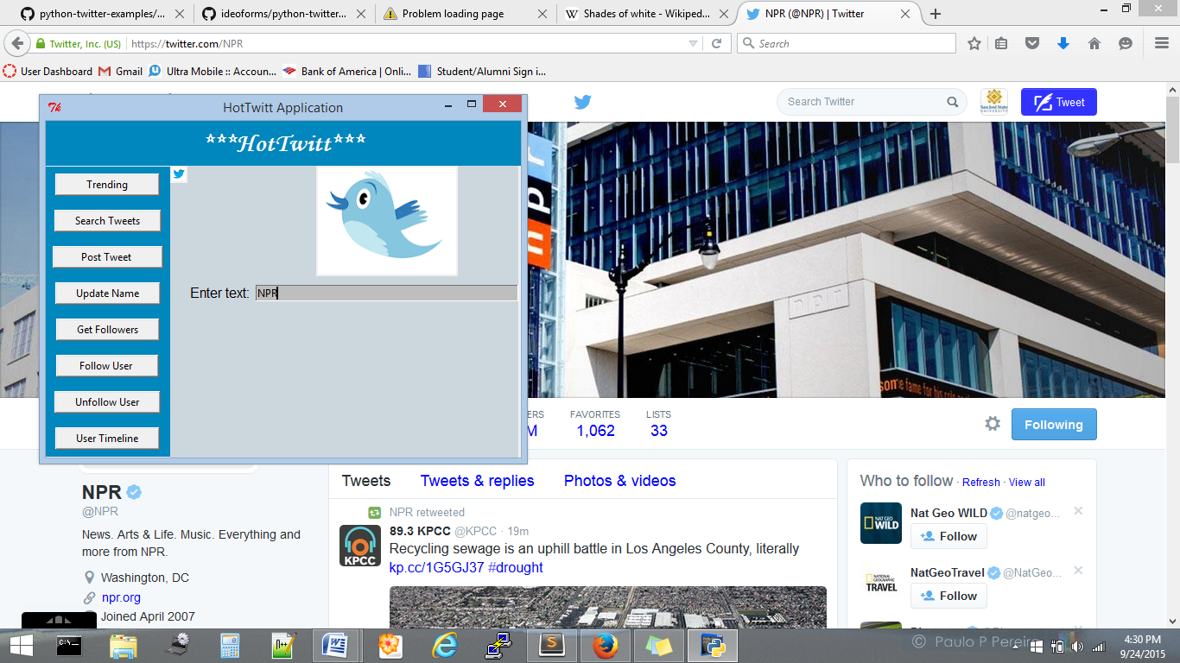

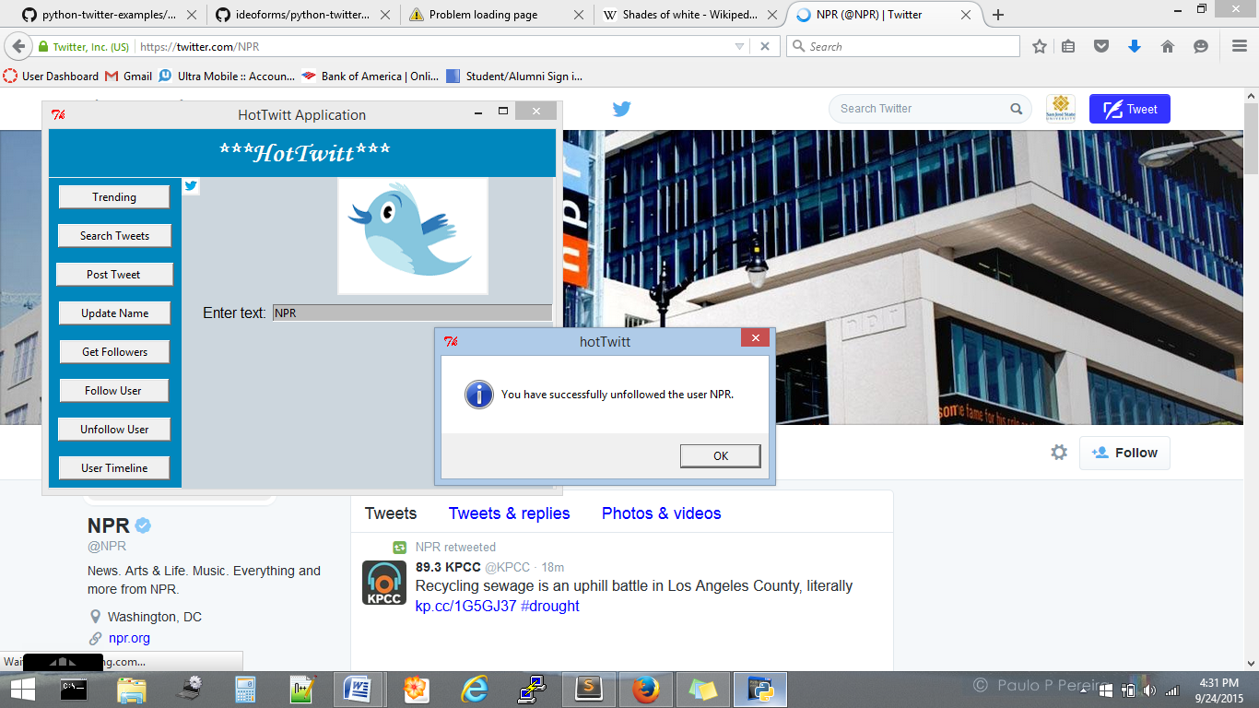

1. To access the User TimeLine of a particular account you can give the user account handle and click on the “User Timeline” Button and get the last 10 status from that user’s timeline.

Note: We can only get user time of a public account and not a private restricted account.

Example: We are getting user time of NASA(@NASA) and we can see last 10 statuses.

